Schedule A

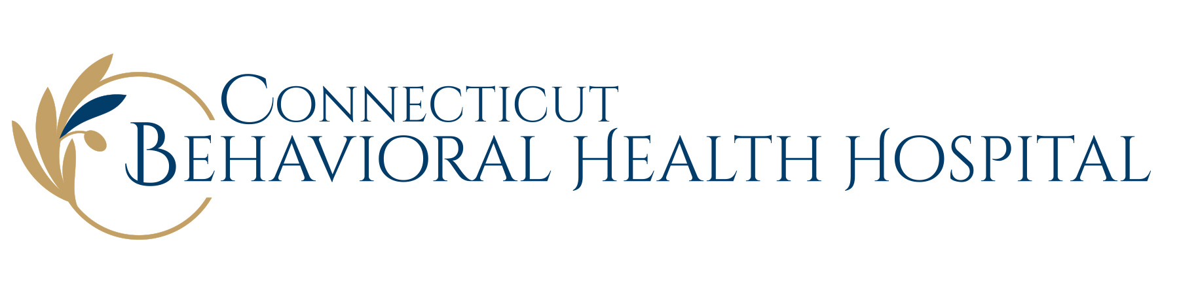
Financial Assistance Table*

To apply for Financial Assistance, the patient (or family) must complete Hebrew Home & Hospital’s Patient Financial Assistance Application, including requested documentation.

Federal Poverty Guidelines effective February 1, 2022 are listed below:

 | Federal Poverty Guideline (100% FPG) | Annual Income at or below 200% of FPG eligible for
Size of Family Unit |  | 100% Free Care
1 | $13,590 | $27,180
2 | $18,310 | $36,620
3 | $23,030 | $46,060
4 | $27,750 | $55,500
5 | $32,470 | $64,940
6 | $37,190 | $74,380
7 | $41,910 | $83,820
8 | $46,630 | $93,260
For each additional family member after 8,
add
 | $4,720 | $9,440

Examples:

Family unit of 1 with an annual income of $25,000 receives 100% free care.

Family Unit of 7 with an annual income of $80,000 receives 100% free care.

*This Table will be adjusted in accordance with annually released changes to the Federal Poverty Guidelines. The current FPG at the time service is provided will be used in the determination of eligibility under the Financial Assistance Policy.

