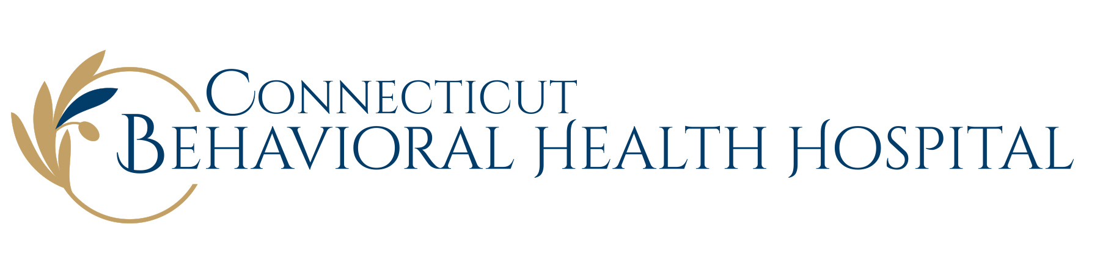
Schedule A
Financial Assistance Table*

To apply for Financial Assistance, the patient (or family) must complete Hebrew Home & Hospital’s Patient Financial Assistance Application, including requested documentation.

Federal Poverty Guidelines effective February 1, 2021 are listed below:

Size of Family Unit | Federal Poverty Guideline (100% FPG) | Annual Income at or below 200% of FPG eligible for  100% Free Care
1 | $12,880 | $25,760
2 | $17,420 | $34,840
3 | $21,960 | $43,920
4 | $26,500 | $53,000
5 | $31,040 | $62,080
6 | $35,580 | $71,160
7 | $40,120 | $80,240
8 | $44,660 | $89,320
For each additional family member after 8,  add | $4,540 | $9,080

Examples:

Family unit of 1 with an annual income of $20,000 receives 100% free care.

Family Unit of 7 with an annual income of $80,000 receives 100% free care.

*This Table will be adjusted in accordance with annually released changes to the Federal Poverty Guidelines. The current FPG at the time service is provided will be used in the determination of eligibility under the Financial Assistance Policy.

